Bug_01:
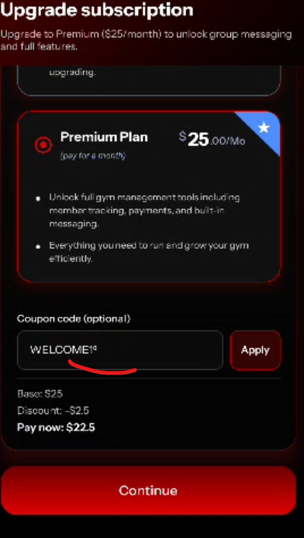
Instead of 0 I write small o and it accept
Bug_02:
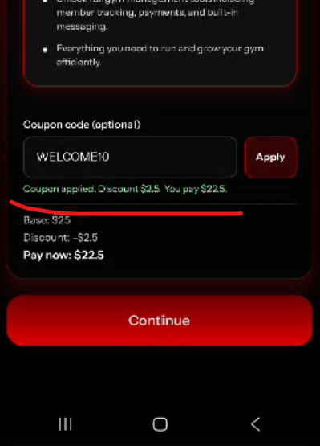
Change the coupon message
Bug_03:
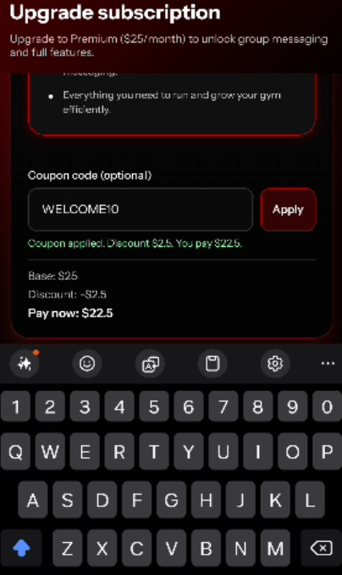
The keypad pad should not b close when user try to scroll down/up
Bug_04:
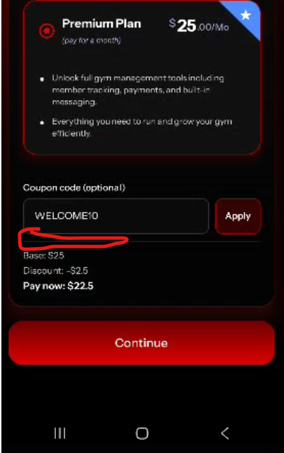
When user enter coupon code then click on continue, then back to this page the coupon message should be appear.

